

<My Project Name>

*A project report submitted for fulfilling the course requirement of*

Environmental Science CH 201

on

The 3rd day of October 2017

By: Rawal Pandey B-243 S174099

Rishav Kumar B-216 S174100

Anup Kolte B-210 S174048

M.A. Mujeeb B-238 S174

**Contents**

i. List of figures

ii. List of tables

iii. Abstract

1. Introduction

2. Literature review

3. The project

3.1 Introduction to the present work

3.2 The work done

3.3 The final product

3.4 Results and discussions

4. Conclusion

5. Bibliography

**List of figures**

1. Predicted trend of oil production by 2060

2. Different types of renewable energy sources

3. Different types of solar collectors

4. Effect of size and curvature of solar concentrator on efficiency

**List of Tables**

1. Effect of size and curvature of solar concentrator on efficiency

ii. Results and discussions

**Abstract**

In these past years, we have seen that the environment related problems are getting bigger and bigger so we need to think about it carefully. Solutions to these problems are the most likely thing to do now we can do that to aware people about these problems and encourage them to solve the problems in their surrounding about environment.

So we thought now a days reaching every person in the world and conveying them about these problems is done only by one thing i.e. internet so we thought of making a environment related website in which we can include various places that we think needed to draw attention of people and conveying them information about it.

**Introduction**

Environment related website includes the environment information of the surrounding.

Environmental information includes information on:

* The state of the elements of the environment, such as air and atmosphere, water, soil, land, landscape and natural sites including wetlands, coastal and marine areas, biological diversity and its components, including genetically modified organisms and the interaction among these elements
* Factors, such as substances, energy, noise, radiation or waste, including radioactive waste, emissions, discharges and other releases into the environment, affecting or likely to affect the elements of the environment
* Measures (including administrative measures), such as policies, legislation, plans, programmes, environmental agreements, and activities affecting or likely to affect the elements and factors referred to above as well as measures or activities designed to protect those elements
* Cost-benefit and other economic analyses and assumptions used for the above measures and activities
* The state of human health and safety, including the contamination of the food chain, where relevant, conditions of human life, cultural sites and built structures that may be affected by the elements of the environment.

We have tried our best to make this website a friendly website having all its elements of environment information.

Our environment is constantly changing. There is no denying that. However, as our environment changes, so does the need to become increasingly aware of the problems that surround it. With a massive influx of natural disasters, warming and cooling periods, different types of weather patterns and much more, people need to be aware of what types of environmental problems our planet is facing.

Global warming has become an undisputed fact about our current livelihoods; our planet is warming up and we are definitely part of the problem. However, this isn’t the only environmental problem that we should be concerned about. All across the world, people are facing a wealth of new and challenging environmental problems every day. Some of them are small and only affect a few ecosystems, but others are drastically changing the landscape of what we already know.

Our planet is poised at the brink of a severe environmental crisis. Current environmental problems make us vulnerable to disasters and tragedies, now and in the future. We are in a state of planetary emergency, with environmental problems piling up high around us. Unless we address the various issues prudently and seriously we are surely doomed for disaster. Current environmental problems require urgent attention.

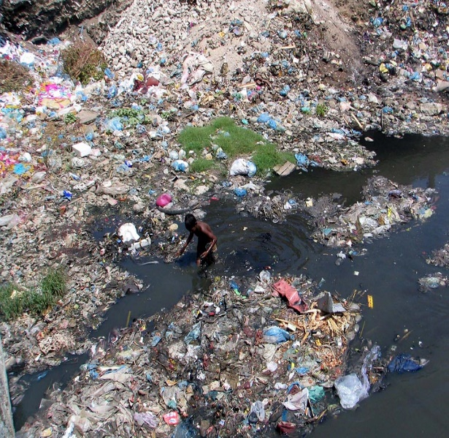 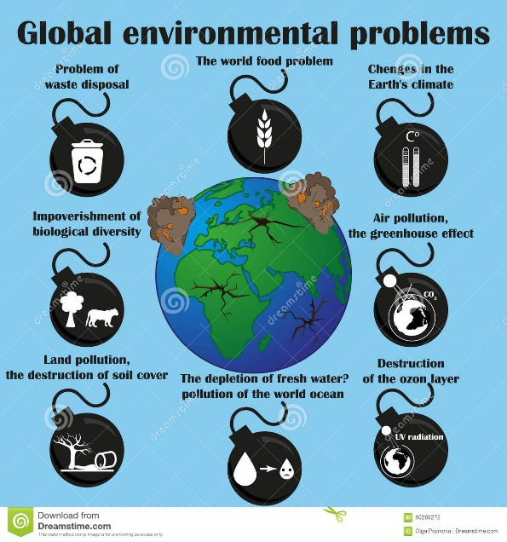

**Literature Review**

**Jared Diamond, *Collapse: How Societies Choose to Fail or Survive*, Penguin Books, 2005 and 2011** described diamond identifies five factors that contribute to collapse: climate change, hostile neighbours, collapse of essential trading partners, environmental problems, and failure to adapt to environmental issues. The root problem in all but one of Diamond's factors leading to collapse is overpopulation relative to the practicable (as opposed to the ideal theoretical) carrying capacity of the environment. The one factor not related to overpopulation is the harmful effect of accidental or intentional introduction of non-native species to a region.

**OCHA ,2016-04-07** said that climate disasters are on the rise. Around 70 percent of disasters are now climate related – up from around 50 percent from two decades ago. These disasters take a heavier human toll and come with a higher price tag.  In the last decade, 2.4 billion people were affected by climate related disasters, compared to1.7 billion in the previous decade. The cost of responding to disasters has risen tenfold between 1992 and 2008. Destructive sudden heavy rains, intense tropical storms, repeated flooding and droughts are likely to increase, as will the vulnerability of local communities in the absence of strong concerted action.

**Sushil and Batra; Batra, V (December 2006)** described that It also studies the prevalent disposal methods used at these sites. The ashes were analysed for the presence of Cr, Mn, Pb, Zn, Cu, Ni and Co and detectable levels of all were found in both fly ash and bottom ash. The concentrations of Cr and Zn were highest while Co concentration was less. The wet disposal method is used in two of the power plants (site 1 and site 3). Neither of the sites uses ash pond lining in the construction of the ash ponds, hence leaching of the heavy metals is possible.

Site 2 has adopted 100% dry disposal system which allows better utilization but incurs additional costs. Better management practices, increased utilization and proper disposal practices need to be undertaken to minimize the adverse environmental impact.

T

The Project

**3.1 Introduction to the present work**

Our project is to make the environmental related website which includes the information about various places of the surrounding which are environment important. From this website we can show photos and videos , all data of related to these places which includes pollution, environmental problems at these places , tourism, some key places which are important as part of environment.

So we make the website having its interface showing the places people want to see the information. Some of our videos of telling information of these places and introduction of them. To demonstrate we added some places like alandi, lonavla ,etc. At that web page information is given on one side and photos on other side. At the bottom of that page we included some videos of our own showing the introduction to these places.

Our motive is to make a website which is sufficient to give information about environment important places.

**3.2 The Work Done**

<All the stages of the work along with the photographs and descriptions>

<All photographs should be marked a figure number and must be included in table of figures>

**3.3 The Final Product**

<All about the final product that is made, its photographs, diagrams, final calculations and working>

**Results and Discussion**

In this project we have come to know that environment related some problems when we go through that information. From the places we included in our project we have identified that Alandi has the most pollution among them an dwe discussed some of its problems.

Such as :

**Indrayani River Pollution :**

Indrayani river originates in the Western Ghats near Lonavla and passes through Kamshet, Talegaon, Dehu, Pimpri Chinchwad and Alandi and later meets the Bhima river. Increasing industrialisation and urbanisation of these areas is increasing pollution levels in the river.   
In its December 3 reply to Savale, the pollution control board has said areas located along the river, such as the Lonavla, Talegaon and Alandi municipal council limits, lack adequate sewage treatment facilities and hence, release their untreated sewage into the water body.

**Alandi Air Quality Index :**

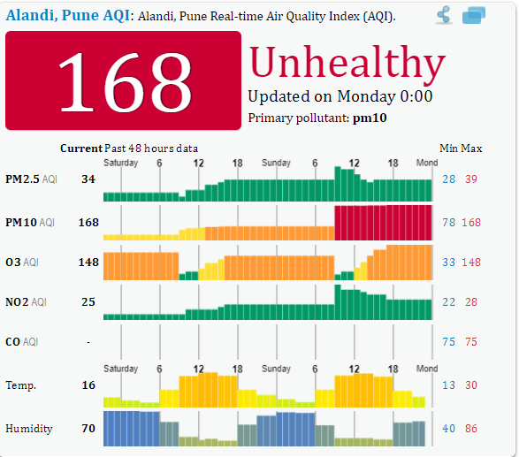

**Conclusion**

We have successfully implemented our project about making a website which tells about environmental related information. In which we come to know how to make the website using programming languages and the most important thing is collecting the information about the places which are environmentally important. Also in that process we come to know the pollution and other factors affecting the environment of our surrounding places. Some information about these places from overall aspect included in them and we should solve environment related problems which we are facing today. So overall our experience was very much interesting and motivating.

**Bibliography**

1. **Brand, Stewart (2009). ‘’Whole Earth Discipline: An Ecopragmatist Manifesto.’’ Viking Penguin. ISBN 978-0-670-02121-5**
2. **‘’Enjoy life while you can’’ Views of James Lovelock, The Guardian, March 1, 2008, Retrieved July 20, 2010**
3. **Johnson, D. L.; Ambrose, S. H.; Bassett, T. J.; Bowen, M. L.; Crummey, D. E.; Isaacson, J. S.; Johnson, D. N.; Lamb, P.; Saul, M.; Winter-Nelson, A. E. (1997). "Meanings of Environmental Terms". Journal of Environmental Quality. 26(3): 581–589**.
4. **Joe Buchdahl. "Atmosphere, Climate & Environment Information Programme". Ace.mmu.ac.uk. Archived from the original on 2010-10-09. Retrieved 2013-03-09.**